**Software Requirements Specification**

**For project LearnHub**

**Prepared by:**

**Trần Tấn Đạt**

**Lê Hữu Huy**

**Nguyễn Phương Tâm Tâm**

**Vũ Mạnh Khải**

**Lê Đức Nam**

**November 11, 2024**

**Table of contents**

1. **Introduction** 1.1 Background 1.2 Business opportunity 1.3 Business Objectives 1.4 Vision Statement
2. **Overall Description** 2.1. Product Perspective 2.2. User Classes and Characteristics 2.3. Operating Environment 2.4. Design and Implementation Constraints 2.5. Assumptions and Dependencies
3. **System Feature** 3.1 Use case 3.2 Use Case Specification
4. **Data Requirements** 4.1 Logical Data Model 4.2 Data dictionary
5. **External Interface Requirements** 5.1 User interfaces 5.2 Software interface
6. **Quality Attributes** 6.1 Usability Requirements 6.2 Performance Requirements 6.3 Security Requirements 6.4 Availability Requirements 6.5 Robustness Requirements 6.6 Wireframe 6.8 Prototype
7. **Swimlane**
8. **State machine**
9. **Sequence diagram**
10. **Class diagram**

**1. Introduction**

**1.1 Background**

Customers who want to buy furniture face many big problems: they don't know all the models of the same type of furniture, they don't know the market price, they can't find a reputable place, and they don't have an overview. Regarding the compatibility between the interiors, there is no accurate estimate between the interior and the space, and the budget cannot be determined. That leads to a bad buying experience, easily leading to mistakes such as buying the wrong item, buying at a higher price, buying it but not being able to use it because it doesn't fit the space, the total cost of buying furniture being exceeded. budget, causing a loss of time and money.

**1.2 Business opportunity**

The traditional way of operating a furniture store is to trade directly at the store, which costs a lot of operating costs. A multi-platform online sales system will be a more optimal solution. The system will help stores easily market and bring in better revenue. Customers can shop and view products more easily. The ability for customers to order home-delivery furniture products in the future will bring more convenience to customers.

**1.3  Business Objectives**

BO-1: Increase revenue by 30% because customers can buy online and have it delivered to their homes. Scale: number of orders per week Meter: Check the system's order history Past: 33% (2023, initial study) Target: Below 20% Stretch: Less than 15%

BO-2: Increase average productive working time by 1 hour for each employee using the app every day within 3 months after initial issuance.

**1.4 Vision Statement**

For customers who want to buy furniture, the home-furni system is a furniture e-commerce site that will accept online orders, schedule showroom viewings or interior design appointments. Unlike the current process, the home-furni system helps customers save more time in viewing orders, making payments and receiving more advice through the use of the app or web.

For staff who want to participate in the company's management processes such as customer account management, order management, warehouse data management, and direct contact with customers. Unlike the traditional paper-based management methods of the past, the system can now easily manage customers and orders more simply.

**2. Overall Description**

**2.1. Product Perspective**

Currently, furniture stores often conduct transactions directly at the store, this is a traditional method of buying and selling with high operating costs. To optimize this process, we propose implementing a multi-platform online sales system, e-Furniture. The e-Furniture system reduces costs associated with the traditional transaction model, including space rental costs and personnel costs. Customers can view and shop for furniture products anytime, anywhere through online platforms. This brings convenience and flexibility to customers. The system allows stores to easily reach and market to target customers through online advertising and promotion strategies. Customers can easily search, compare, and choose products conveniently. The system also provides interactive features such as reviews and comments, helping to enhance the online shopping experience. The future will see the ability to order and quickly deliver products to your door, bringing a classy and convenient shopping experience to customers. Deploying a multi-platform online furniture sales system not only helps optimize business processes but also opens up many new opportunities. We believe that integrating technology into your business model will bring greater development and efficiency to your furniture store.

Untitled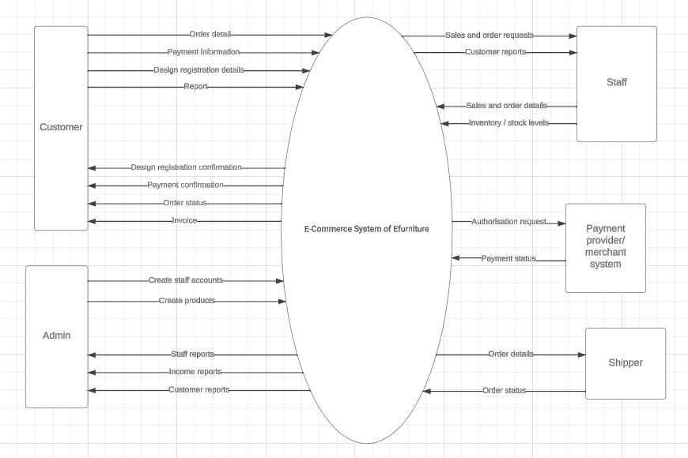

**2.2. User Classes and Characteristics**

* Customer: Customers are people who need to buy furniture for their living space, including products such as sofas, dining tables, beds, cabinets, and decorative items. They can place multiple furniture orders at any location. Orders can be made by customers through the store's website.
* Staff: They will receive orders from e-Furniture System, confirm, prepare and request delivery of orders. They will also participate in data management and reporting to administrators.
* Administrator: They are the people who will monitor and manage the system. Receive reports and handle related issues.
* Delivery person: Once the order has been approved and packaged, the delivery person will be asked to pick up and deliver the order to the orderer. The delivery person's interactions are mainly about the delivery process and confirmation of whether the order has been delivered or not.

**2.3. Operating Environment**

OE-1: The e-Furniture System shall operate correctly with the following web browsers: Google Chrome; Microsoft Edge; Apple Safari; Opera; Mozilla Firefox; and Samsung Internet.

OE-2: The e-Furniture System shall permit user access from the corporate Intranet, from a VPN Internet connection, and by Android, iOS, and Windows smartphones and tablets.

**2.4. Design and Implementation Constraints**

CO-1: The e-Furniture System shall operate on a server running the current corporate-approved version of the JavaScript framework Node.js.

CO-2: The Electronic Furniture system needs to be compatible and work correctly with the MongoDB database.

**2.5. Assumptions and Dependencies**

AS-1: The system can accommodate varying traffic levels throughout the day, with possible spikes during promotional events, holidays, or weekends.

AS-2: Users can browse the site without making a purchase, and can add items to the cart without completing the purchase.

AS-3: Website optimized for various devices (desktop, tablet, smartphone) and compatible with popular web browsers (Chrome, Firefox, Safari, Edge).

AS-4: The website must load quickly to provide a smooth user experience and be able to handle concurrent user requests without significant crashes or slowdowns.

AS-5: Users can make secure payments using various methods (credit/debit cards, PayPal, etc.). The reliable payment gateway complies with security standards to protect user data.

AS-6: The system can accurately monitor inventory levels to prevent overselling, and warn when inventory levels are low to reorder products promptly.

AS-7: Users can easily search for products using keywords, filters, and categories.

AS-8: Users know shipping costs and delivery times, and can track their order status.

AS-9: The system ensures compliance with relevant laws and regulations, such as data protection (e.g. GDPR), consumer rights, and taxes.

AS-10: The system accommodates future developments in users, products, and features.

DE-1: Users need a stable internet connection to access the website and make purchases.

DE-2: The website needs reliable hosting to ensure uptime and performance.

DE-3: The website needs a domain registrar to register and manage the website's domain name (e.g. [www.yourfurniturestore.com](http://www.yourfurniturestore.com/)).

DE-4: Integration with payment gateways (e.g. PayPal, Stripe, Square) is essential to securely process online payments.

DE-5: The website needs a database system (e.g. MySQL, PostgreSQL, MongoDB) to store product information, user data, order details, and other related data.

DE-6: The website should implement security solutions such as firewalls, intrusion detection systems, and malware scanning that help protect your website from security threats.

**3. System Feature**

**3.1 Use case**

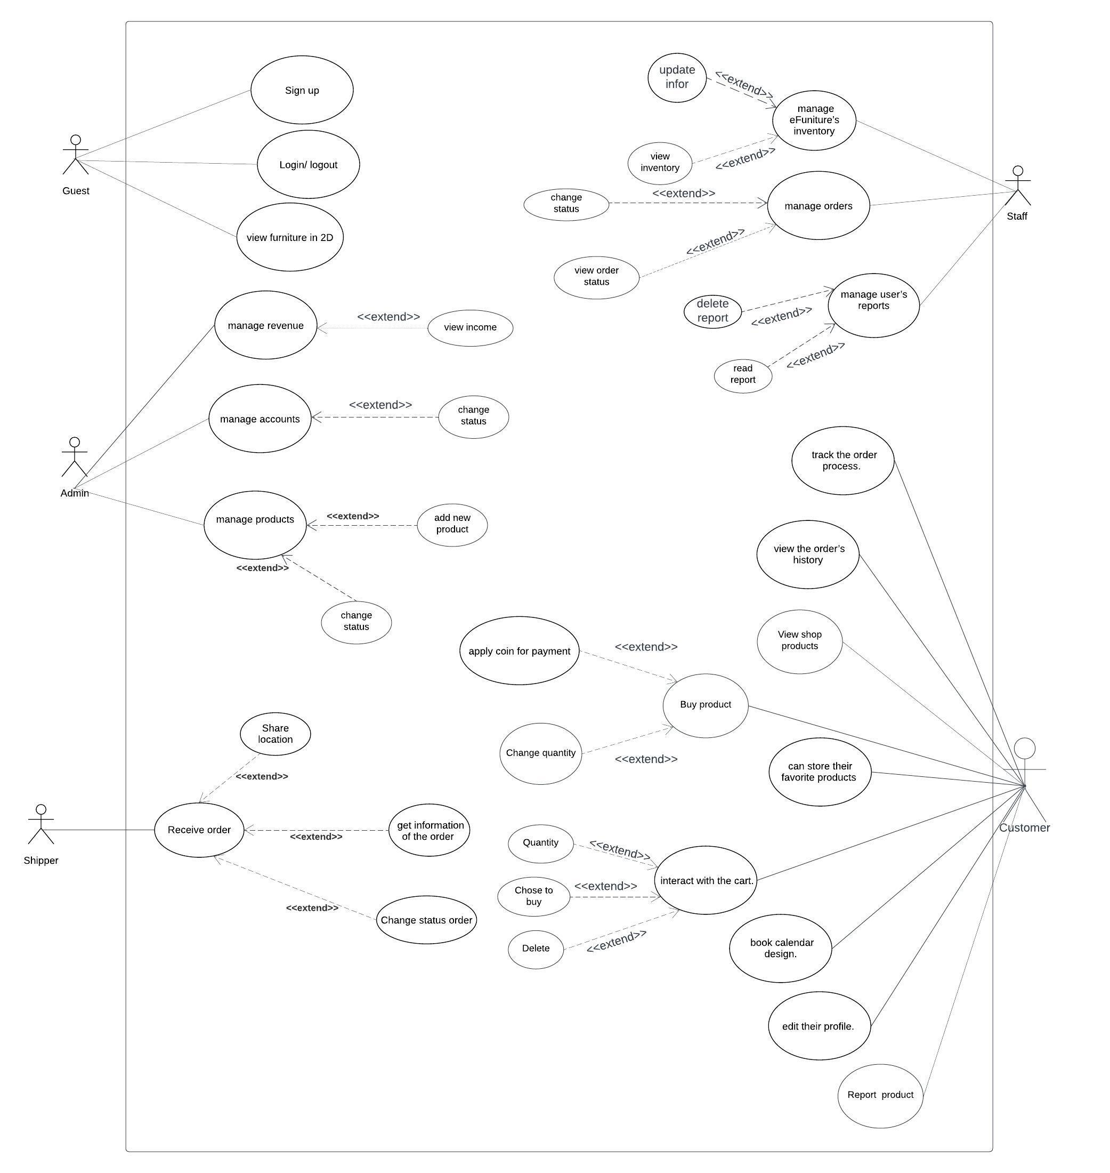

**3.2 Use Case Specification**

* **Use case for order (Nguyen Anh Huy)**

| ID and Name: | Order |
| --- | --- |
| Created By: | Nguyen Anh Huy |
| Date Created: | 21/1/2024 |
| Primary Actor: | Customer |
| Secondary Actors: | Product storage system |
| Description: | Customers buy selected items in the shopping cart. Choose to buy multiple items, and edit the order quantity. |
| Trigger: | The customer would like to place an order |
| Preconditions: | 1. Customer must be logged to system2. Customers need to choose the product |
| Postconditions: | 1. All items that the customer chooses are included in the bill. The quantity of products after pressing checkout is checked to see if there is enough quantity of goods as required. |
| Normal Flow: | 1. The customer accesses the system's website or mobile application and logs into their account (if they have one).2. The customer searches for the desired product using the search function or browses through product categories.3. The customer selects the product they want to purchase and adds it to the shopping cart.4. The customer reviews the shopping cart to ensure accurate information and selects various options if available (e.g., size, color).5. The customer chooses a payment method and enters payment information (if not already stored in the system) or selects a previously saved payment method. (Payment methods: PayPal, pay directly)6. The system verifies the order information and creates a new order.7. The system displays a confirmation message for the order and sends an order confirmation email to The customer.8. The customer can track the order status on the website or application. |
| Alternative Flows: | **Insufficient Inventory:** - If the inventory is insufficient (e.g., out of stock), the system prompts The customer with an error message.- The customer is redirected to the product page or notified of alternative products.- The customer can choose an alternative product, adjust quantities, or cancel the purchase.- They return to the main flow to complete the purchase.  **Payment Authorization Failure:**- If the payment authorization fails (e.g., insufficient funds, declined card), the system notifies the customer with an error message.- The customer is prompted to update payment information, choose an alternative payment method, or cancel the purchase.- If the customer chooses an alternative payment method, the system retries the authorization process.- The customer returns to the main flow to finalize the purchase. |
| Exceptions: | 1. If the payment information is invalid or there is an inventory issue, the system notifies The customer of the error and requests them to correct the information or choose an alternative product.2. If the payment process fails, the system notifies The customer and guides how to resolve the issue. |
| Priority: | High |
| Frequency of Use: | Approximately 300 users, an average of one usage per day. The peak usage load for this use case is between 12:00 A.M. and 7:00 P.M. local time |
| Business Rules: | 1. Payment Security Rule: The system must adhere to industry-standard encryption protocols, employ secure payment gateways, and comply with relevant security regulations (such as PCI DSS) to safeguard users' payment information.2. Inventory Management Rule: The system must decrement product quantities in real-time as users make purchases. In case of low stock or unavailability, the system should promptly update product status and inform users, preventing them from purchasing out-of-stock items.3. If an order is to be delivered, the patron must pay by payroll deduction.4. All items in an order must be paid for using the same payment method.5. Payment methods: identify accepted payment methods, which payment methods are using Paypal online payment method, and cash on delivery.6. Data Security and Compliance: adhere to data security standards and compliance regulations to protect sensitive customer information.7. Require a clear confirmation process for payments to ensure that both the customer and the business have a record of the transaction. |
| Other Information: | 1. Customers can cancel the order process before the goods are delivered if there is a legitimate reason.2. Customers can see all the items they have previously ordered and can re-order. |
| Assumptions: | Customer Authentication: - Customers are assumed to have valid and secure authentication credentials (username/password or other authentication methods) to access their accounts during the purchase process. |

* **Use case for managing accounts (Do The Hieu)**

| ID and Name: | **UC-1 Manage Accounts** |
| --- | --- |
| Created By: | Đỗ Thế Hiếu |
| Primary Actor: | Administrator |
| Date Created: | 21/01/24 |
| Secondary Actors: | User Database System |
| Description: | An Administrator accesses the User Management System to manage user accounts, including creating new accounts, updating existing account information, and deactivating accounts as needed. |
| Trigger: | An Administrator indicates the need to manage user accounts. |
| Preconditions: | PRE-1. The administrator is logged into the User Management System.  PRE-2. The administrator has the necessary permissions to manage user accounts. |
| Postconditions: | POST-1. Changes to user accounts are stored in the User Database System.  POST-2. User information is updated based on the changes made by the Administrator. |
| Normal Flow: | **1.0 Create a New User Account** 1. The administrator selects the option to create a new user account. 2. The system prompts the Administrator to enter the necessary information for the new user (username, email, role, etc.). 3. Administrator submits the information. 4. The system validates the information and creates a new user account. 5. The system displays a confirmation message, including the new user's details. 6. The administrator has the option to create another user account (return to step 1) or exit the account creation process.  **2.0 Update Existing User Account** 1. The administrator selects the option to update an existing user account. 2. The system displays a list of existing users with relevant details. 3. The administrator selects the user account to be updated. 4. The system allows the Administrator to modify user details such as email, role, or password. 5. Administrator submits the changes. 6. The system validates and updates the user account. 7. System displays a confirmation message. 8. The administrator has the option to update another user account (return to step 1) or exit the update process.  **3.0 Deactivate User Account** 1. The administrator selects the option to deactivate a user account. 2. The system displays a list of existing users with relevant details. 3. The administrator selects the user account to be deactivated. 4. System prompts for confirmation. 5. The administrator confirms the deactivation. 6. The system updates the user account status to "Deactivated." 7. System displays a confirmation message. 8. The administrator has the option to deactivate another user account (return to step 1) or exit the deactivation process. |
| Alternative Flows: | **1.1 Bulk User Account Creation** 1. The administrator chooses to create multiple user accounts. 2. System allows the Administrator to upload a CSV file with user details. 3. The system validates the file and creates multiple user accounts. |
| Exceptions: | **1.0.E1 Invalid User Information** - If entered user information is invalid, the system informs the Administrator and returns to the data entry step. - The administrator has the option to correct the information and proceed.  **1.0.E2 User Account Already Exists** - If the system detects that the username or email already exists, it prompts the - - - Administrator to choose a different username or email. - Administrator adjusts the information and proceeds. |
| Priority: | High |
| Frequency of Use: | Frequency of Use: Approximately 2 administrators, an average of five usages daily. Peak usage load is between 2:00 A.M. and 4:00 A.M. local time. |
| Business Rules: | 1. Each user account has a distinct username or employee ID.  2. The password must be complex, including alphanumeric characters and periodic changes.  3. Restrict administrators to account management within assigned departments.  4. Send messages to stakeholders to announce when an account is deactivated.  5. Store detailed audit logs of account management activities for security.  6. The administrator has to report the reason to the system for the deactivation of any account |
| Other Information: | 1. The system maintains an audit log of all account management activities.  2. Administrators can only update or deactivate user accounts within their assigned department.  3. Password-related changes trigger an automated email to the user for security purposes. |
| Assumptions: | Administrator Training and Authorization: This assumption prioritizes that administrators using the User Management System have received sufficient training on its functionalities and are aware of the organization's policies regarding user account management. Additionally, it assumes that administrators have the necessary permission to perform account management tasks. This is crucial for ensuring the secure and proper handling of user accounts, minimizing the risk of errors or unauthorized access. |

* **Use case for accepting an order (Nguyen Viet Hoang)**

| ID and Name | UC-accept an order |
| --- | --- |
| Create by | Nguyễn Việt Hoàng |
| Primary actor | Staff |
| Date created | 20/01/2023 |
| Secondary Actors | Customer |
| Description | Employees log in to the website and see if a bulk order has been placed, then can check the quantity of furniture to approve or cancel the customer's order. |
| Trigger | The customer must have a lot of orders for interior |
| Pre-condition | 1.  Staff must be logged into the system  2.  Staff must check the order status |
| Postcondition | 1. The order has been updated in the database with the order status as approved  2. The number of products will be updated in the database to reflect the correct quantity available in the store |
| Basic flow | 1. Staff views order list:  2 . The employee accesses the screen with a list of orders that need to be processed. Select the order to process: The employee selects an order from the list to view details.  3. View order details: The system displays detailed information about the order, including items such as product, price, shipping address, etc.  4. Decide to Accept or Cancel the order: The employee decides whether to agree and confirm the order or cancel it. If the employee selects Agree: The system confirms and updates the order's status to "Confirmed". Send a confirmation message to the customer. If the employee chooses Cancel: The system confirms and updates the order's status to "Cancelled". Send cancellation notices to customers.  5. Confirm and complete: The system confirms that the order's status has been updated successfully. Complete the process. |
| Alternative flow | If an error occurs during processing, the system will display an error message and start over |
| Exception flow | Exception Flow 1: Error connecting to the database   During order processing, the system encountered an error accessing the database. The system displays an error message and asks the employee to try again later or contact the technical department to resolve the problem.  Exception Flow 2: Invalid order data   The employee reviews the order and discovers that the data is invalid or important information is missing. The system displays an error message and requires the employee to enter complete and accurate information before confirming the order. These exception flows help manage and handle exception situations that may occur while employees process orders, ensuring that they receive notifications and support when needed to resolve the issue. |
| Priority | High |
| Frequency of Use | Approximately 100 users, an average of one usage per day. The peak usage load for this use case is between 7:00 P.M. and 10:00 P.M. |
| Business rule | 1. Confirm inventory status: The quantity of products in the order must be less than or equal to the quantity of products in stock  2. Check payment policy: Payment on delivery Pay via wallet: PayPal  paying through bank Payment method via wallet via bank requires payment before accepting the order  4. Store order history: Store the status of each order for easy control Status: accepted, delivered, successfully, canceled, processing  5. When the value of the order is greater than 10 million, the staff must call to confirm with the customer |

* **Use case for interacting with the cart (Nguyen Le Phuong Nam)**

| ID and Name: | **UC-Interact with the cart** |
| --- | --- |
| Created By: | Nguyen Le Phuong Nam |
| Primary Actor: | Customer |
| Date Created: | 22/01/24 |
| Secondary Actors: |  |
| Description: | A Customer accesses the Home Vintage Website, views available products, adds items to the shopping cart and completes the order for delivery to a specified location within a given time frame. |
| Trigger: | A Customer expresses the intent to add items to the shopping cart. |
| Preconditions: | 1. Customer is logged into the Store Inventory Website.  2. Customer has selected items for purchase. |
| Postconditions: | 1. The shopping cart is updated with the selected items.  2. Inventory of available products is adjusted.  3. Order is stored with a status of "Confirmed." |
| Normal Flow: | **1.0 Add Items to Cart**  1.      Customer navigates to the Store Inventory Website. 2.      Customer browses available products and selects items to purchase.  3.      Customer adds selected items to the shopping cart. 4.      Customer indicates that the cart is complete and proceeds to checkout.  5.      1.1: Customer requests to modify the cart.  6. The website displays the list of items in the cart, individual prices, and the total amount including taxes and delivery charges. 7.      Customer confirms the cart (continue normal flow) or requests to modify the cart (return to step 2). |
| Alternative Flows: | **1.1 Modify Cart** - Customer requests to modify the cart. - Return to step 2 of the normal flow. |
| Exceptions: | **1.0.E1 Website Unreachable**  1. Notify the Customer that the website is currently unreachable or experiencing technical issues.  2. If the Customer decides to cancel the ordering process, terminate the use case. |
| Priority: | High |
| Frequency of Use: | Varies, depending on customer demand and promotional events. |
| Business Rules: | **1. Item Availability Rule:** • Only items marked as "in stock" can be added to the cart. • If the product is out of stock, it cannot be added to the cart and will not be displayed on the screen.  **2. Quantity Limitation Rule:** • Customers cannot add a quantity of items to the cart that exceeds the available stock for that item. • The quantity must be a positive integer.  **3. Validation of Item Rule:** • Only valid furniture items can be added to the cart. • The system should verify that the selected item exists in the product catalog.  **4. Price Adjustment Rule:** • The system should automatically update the total price of the order when an item is added to the cart. • Total = ∑(quantity * price)  **5. Cart Persistence Rule:** • If the customer is not logged in, the system still allows users to add products to the shopping cart, but only temporarily. Users who log in to their account will have the products in the shopping cart updated when they have not yet logged in to the shopping cart. log in.  **6. Discount Application Rule:** • Apply any applicable discounts or promotions to the items in the cart.  **7. Validation of Order Total Rule:** • The system should perform a final validation to ensure that the total cost of items in the cart aligns with any promotional rules, discounts, or pricing policies in place.  **8. Item Removal Rule:** • Allow customers to remove items from the cart before proceeding to checkout. |
| Other Information: | 1.      The customer has the option to withdraw from the ordering process at any point prior to confirmation.  2. The customer will have the choice to repeat an earlier order or keep the cart for later use.  3. Taking into account the earliest available slot, the default delivery date and time are recommended. |
| Assumptions: | Assume that 10 percent of Customers will utilize the "Save for Later" feature based on historical data. |

* **Use case for managing user’s report (Nguyen Hoang Dat)**

| ID and Name: | **UC-6 Manage User’s Report** |
| --- | --- |
| Created By: | Nguyễn Hoàng Đạt |
| Primary Actor: | Staff |
| Date Created: | 21/01/2024 |
| Secondary Actors: | e-Funiture Inventory System |
| Description: | Staff access the eFuniture Inventory System from the company intranet or home, reading and deleting all reports from customers about a specific product. |
| Trigger: | Staff wants to read or delete reports from customers. |
| Preconditions: | PRE-1. Staff is logged into the eFuniture Inventory System.  PRE-2. The staff has the necessary permissions to manage user accounts. |
| Postconditions: | POST-1. All the reports for a particular product are displayed  POST-2. Reports that the staff has deleted are not displayed. |
| Normal Flow: | **1.0 Read report**  1. Staff asks to see all the products.  2. eFuniture displays all products.  3. Staff chooses 1 product.  4. eFuniture displays detailed information about that product.  5. Staff chooses to view all reports.  6. eFuniture views all customer reports about that product.  **2.0 Delete Report**  1. Perform all steps as 1.0 in normal flow.  2. Choose to delete a specific report.  3. System warning confirms deletion.  4. Staff confirms deletion and returns to step 6 in the 1.0 in normal flow. |
| Alternative Flows: | **1.1 Read the report from the notification.**  1. Staff choose to see all the latest reporting notifications.  2. System displays all report messages.  3. Staff chooses specific notifications.  4. System displays report details.  **2.1 Delete multiple reports.**  1. Perform all steps as 1.0 in normal flow.  2. Select multiple reports and delete them.  3. Return to step 3 in 2.0 in normal flow.  **2.2 Delete the report from the notification.**  1. Perform all steps as 1.1 in alternative flows.  2. Perform steps 2 to 4 as 2.0 in normal flow. |
| Exceptions: | **1.0.E1 Deleted reports.**  1. Staff chooses to read the deleted report in notifications.  2. System announces that the report has been deleted.  3. Restart the use case. |
| Priority: | High |
| Business Rules: | 1. Only staff can manage the user's report.  2. Customers can only report products that they have purchased. 3. Customers can only report a product according to the number of transactions with that product. |
| Other Information: | 1. All reports must be updated regularly in real-time |

**4. Data Requirements**

**4.1 Logical Data Model**

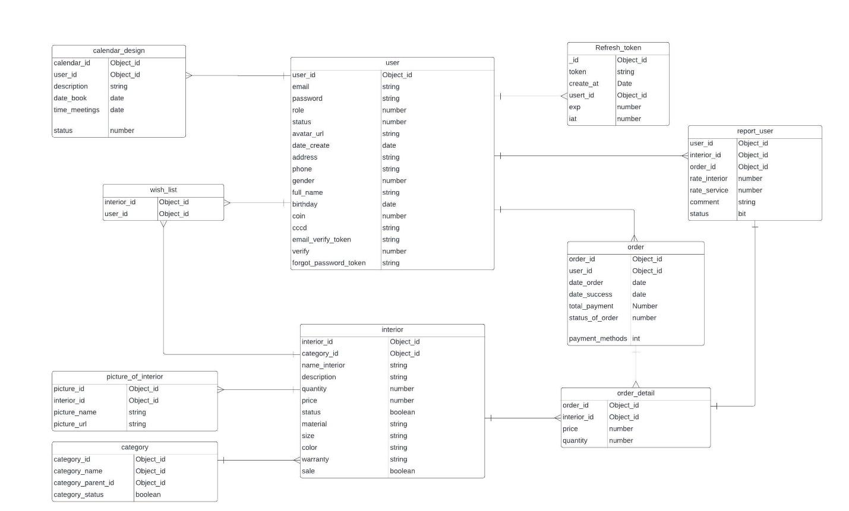

**4.2 Data dictionary**

* **Nguyen Anh Huy - Report**

| **Data Element** | **Description** | **Composition or Data Type** | **Length** | **Values** |
| --- | --- | --- | --- | --- |
| report_user | contains report information from users | user_id+ |  |  |
| interior_id+ |  |  |  |  |
| order_id+ |  |  |  |  |
| rate_interior+ |  |  |  |  |
| rate_sevirce+ |  |  |  |  |
| comment+ |  |  |  |  |
| status |  |  |  |  |
| user_id | unique identifier for each account. | Object_id | 24 | automatic |
| interior_id | unique identifier for each interior. | Object_id | 24 | automatic |
| order_id | unique identifier for each order. | Object_id | 24 | automatic |
| rate_interior | Rate the item using a scale of 5 | int |  |  |
| rate_service | Rate the service using a scale of 5 | int |  |  |
| comment | unique identifier for each account. | String |  |  |
| status | gender of the account owner | boolean | 1 | true: present  false: Hidden |

* **Nguyen Hoang Dat – Order**

| Data Element | Description | Composition or Data Type | Length | Values |
| --- | --- | --- | --- | --- |
| Order | contains information about the order including buyer, amount, order and delivery time, order status, and person in charge of the order | order_id + user_id + date_order + date_success + total_payment + status_of_order + payment_methods |  |  |
| order_id | unique identifier for each order. | String | 8 |  |
| user_id | a unique identifier associated with each user in a database. Customer only in this table | String | 8 |  |
| date_order | store the date and time when an order was placed. | Date | yyyy-MM-dd hh:mm:ss | local time; hh:0-23 |
| date_success | date associated with the successful completion of the order | Date | yyyy-MM-dd hh:mm:ss | local time; hh:0-23 |
| total_payment | the total amount of money paid for an order | double |  |  |
| status_of_order | the current status or state of an order | bit | 1 | 0: In process 1: Success |
| payment_methods | refers to a set of options or choices available for customers to make payments when placing an order in an online shop or e-commerce system. | int |  |  |

* **Do The Hieu - User**

| **Data Element** | **Description** | **Composition or Data Type** | **Length** | **Values** |
| --- | --- | --- | --- | --- |
| user_id | object_id | object_id |  |  |
| email | User's email address | String | 255 | Alphanumeric, Required |
| password | User's password | String | 255 | Encrypted, Required |
| role | Role of the user | number |  | 1: Admin, 2: Moderator, 3: User, etc. |
| status | Status of the user account | number |  | 0: Inactive, 1: Active, 2: Suspended, etc. |
| avatar_url | URL to the user's avatar image | String | 255 | URL format, Optional |
| date_create | Date when the account was created | Date | 10 | Date format: YYYY-MM-DD |
| address | User's address | string | 255 |  |
| phone | User's phone number | string | 20 | Numeric, Required |
| gender | User's gender | number |  | 0: Unknown, 1: Male, 2: Female, etc. |
| full_name | User's full name | string | 100 | Required |
| birthday | User's date of birth | date |  | Date format: YYYY-MM-DD |
| coin | Amount of virtual currency associated with the user | number |  | Numeric |
| CCCD | Citizen Card number (if applicable) | string | 20 | Alphanumeric |
| email_verify_token | Token for email verification | string | 255 |  |
| verify | Verification status of the user | number |  | 0: Unverified, 1: Verified, etc. |
| forgot_password_token | Token for forgot password process | string | 255 |  |

* **Nguyen Le Phuong Nam - Order detail**

| **Data element** | **Description** | **Composition or Data Type** | **Length** | **Value** |
| --- | --- | --- | --- | --- |
| order_id | Unique identifier for each order | String | 24 | Auto-incremented |
| interior_id | Unique indetifier for each interiors | String | 24 | required, Auto-incremented |
| price | Price of interior | Int |  | required |
| quantity | quantity of interior | Int | 20 | required |

* **Nguyen Viet Hoang - Interior**

| **Data element** | **Description** | **Composition or Data Type** | **Length** | **Value** |
| --- | --- | --- | --- | --- |
| interior_id | Unique identifier for each interior | String | 24 | Auto-incremented |
| category_id | Unique identifier for each category | String | 24 | must be required |
| interior_name | name to call interior | String | 5-30 | Alphanumeric, Required |
| description | more detail about that interior | String | 50-100 | Alphanumeric, Required |
| quantity | quantity of interior | int | 10 | Numeric, Required |
| price | price of interior | double | 13 | Numeric, Required |
| material | material of interior | String | 5-15 | Alphanumeric, Required |
| size | size of interior | String | 5-25 | Alphanumeric, Required |
| color | color of interior | String | 5-15 | Alphanumeric, Required |
| warranty | warranty of interior | String | 5-10 | Alphanumeric, Required |
| status | status of interior | int | 1 | 0 : Stock,  1 : Sold out,  2 : Stop bussiness |

**5. External Interface Requirements**

**5.1 User interfaces**

UI-1: The website will allow complete navigation and selection of furniture items using a mouse alone or in addition to using a mouse and keyboard combination.

**5.2 Software interface**

SI-1: Furniture inventory system

* SI-1.1: Home-furniture will transmit the quantity of furniture ordered to the System through the programming interface.
* SI-1.2: Home-furniture checks the quantity and condition of furniture for customers to place orders

**6. Quality Attributes**

**6.1 Usability Requirements**

* USE-1: The web application shall provide clear and intuitive navigation menus and links to allow users to easily browse through product categories, view product details, and add items to their shopping cart.
* USE-2: The system shall ensure that all text, buttons, and interactive elements have appropriate contrast ratios and font sizes to ensure readability and accessibility for users with visual impairments.
* USE-3: The web application shall support responsive design principles and shall be compatible with a range of devices and screen sizes, including desktops, laptops, tablets, and smartphones.
* USE-4: The system shall provide users with the option to customize their browsing experience, including the ability to filter products by price, category, brand, and other relevant attributes.
* USE-5: The web application shall provide informative and helpful error messages to users in case of form submission errors or invalid input, guiding them on how to correct the issue.
* USE-6: The system shall offer multiple payment options, including credit/debit cards, PayPal, and other popular payment gateways, to accommodate user preferences and enhance convenience.
* USE-7: The web application shall include a user-friendly checkout process with clear steps and progress indicators, allowing users to review their order details, apply discounts, and select shipping options before completing the purchase.
* USE-8: The system shall provide users with the ability to track the status of their orders in real-time, including order processing, shipping, and delivery updates, via email notifications and a dedicated order tracking page.
* USE-9: The web application shall offer comprehensive help documentation and support resources, including FAQs, tutorials, and contact information for customer support, to assist users in resolving issues and inquiries promptly.
* USE-10: The system shall allow users to provide feedback and ratings for products and overall shopping experience, facilitating continuous improvement and enhancing user engagement and satisfaction.

**6.2 Performance Requirements**

* PER-1: The system shall accommodate a total of 500 users and a maximum of 150 concurrent users during the peak usage time window of 10:00 A.M. to 12:00 P.M. local time, with an estimated average session duration of 10 minutes.
* PER-2: 90% of webpages generated by the eFurniture System shall download completely within 3 seconds from the time the user requests the page over a 50Mbps or faster Internet connection.
* PER-3: The system shall display confirmation messages to users within an average of 2 seconds and a maximum of 5 seconds after the user submits information to the system.

**6.3 Security Requirements**

* SEC-1: All network transactions that involve financial information or personally identifiable information shall be encrypted using TLS 1.2 or higher per industry standards.
* SEC-2: Users shall be required to log in to the eFurniture System for all operations except browsing product catalog pages.
* SEC-3: Only authorized administrators shall be permitted to manage user accounts and system configurations, per the RBAC (Role-Based Access Control) model.
* SEC-4: The system shall enforce strong password policies, including a minimum length of 8 characters, with a combination of uppercase letters, lowercase letters, numbers, and special characters.
* SEC-5: The system shall implement rate limiting mechanisms to prevent brute force attacks on login pages, with a maximum of 5 failed login attempts allowed within a 5-minute window.

**6.4 Availability Requirements**

* AVL-1: The e-Furniture shall be available at least 98% of the time between 5:00 A.M. and midnight local time and at least 90% of the time between midnight and 5:00 A.M. local time, excluding scheduled maintenance windows.
* AVL-2: The eFurniture system claims 99.99% annual uptime without problems.
* AVL-3: The e-furniture system requires recovery within 30 minutes from the time of failure.
* AVL-4: The eFurniture system requires a data backup and recovery process in place to ensure recovery after problems.
* AVL-5: The e-furniture system requires the ability to automatically switch to a backup system when the main system fails.
* AVL_6: The eFurniture system requires monitoring and alerts when the system has problems, sent via email or text message,...

**6.5 Robustness Requirements**

* ROB-1: If the connection between the user and the eFurniture System is broken before a new order is either confirmed or terminated, the eFurniture System shall enable the user to recover an incomplete order and continue working on it.
* ROB-2: If a payment transaction fails, the eFurniture System shall notify the user of the failure, provide a clear reason for the failure, refund expenses and vouchers if used, recover, and continue working on an incomplete order.
* ROB-3: If a user's session times out due to inactivity, the eFurniture System shall securely log the user out, preserving the shopping cart contents. Upon re-login, the system should prompt the user to restore the previous session or start a new one.
* ROB-4: The eFurniture system will support 5000 concurrent users without sacrificing performance. In case the system capacity is reached, the platform will display an overload message, store unfinished processes if any, and ask the user to redo the operation later.

**6.6 Wireframe**

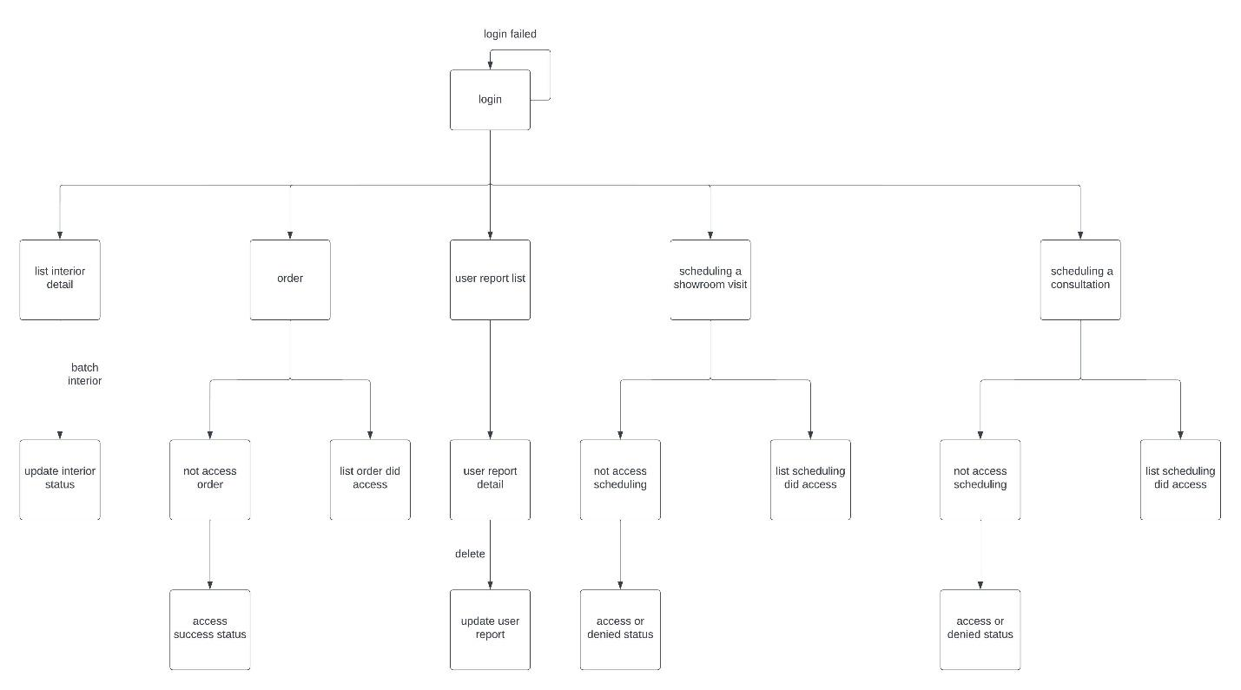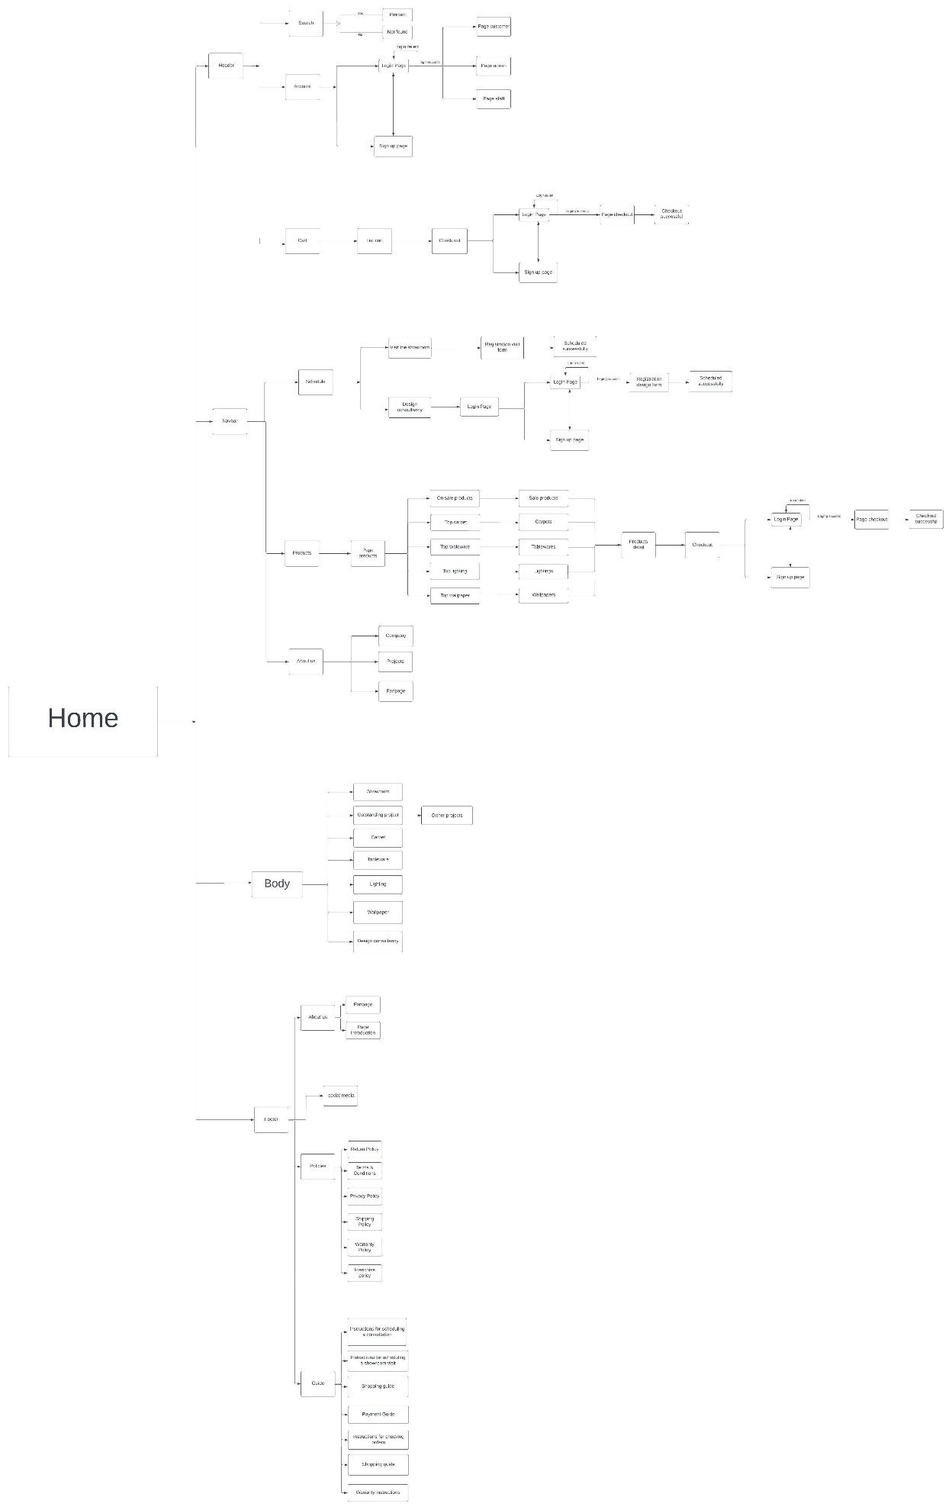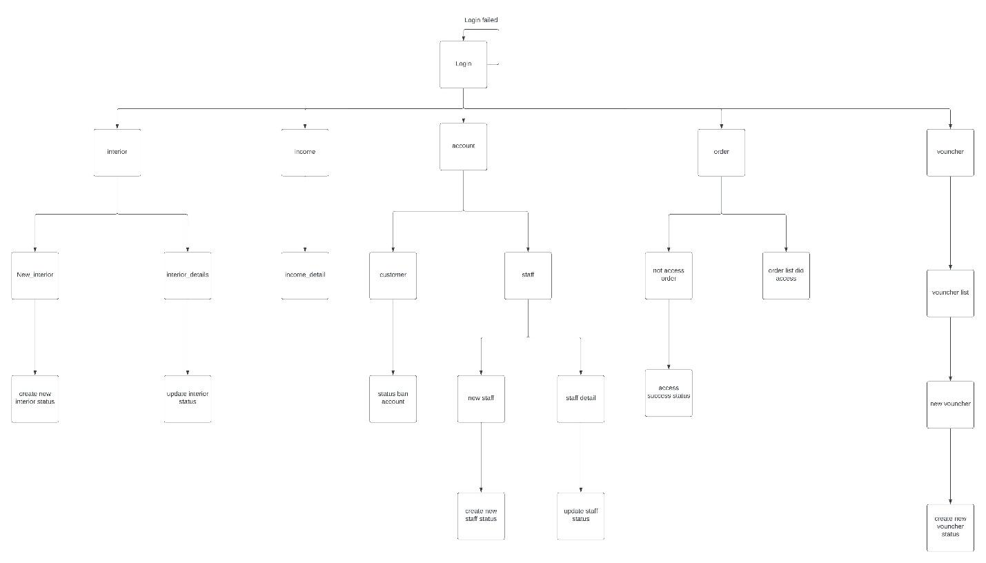





**6.8 Prototype**

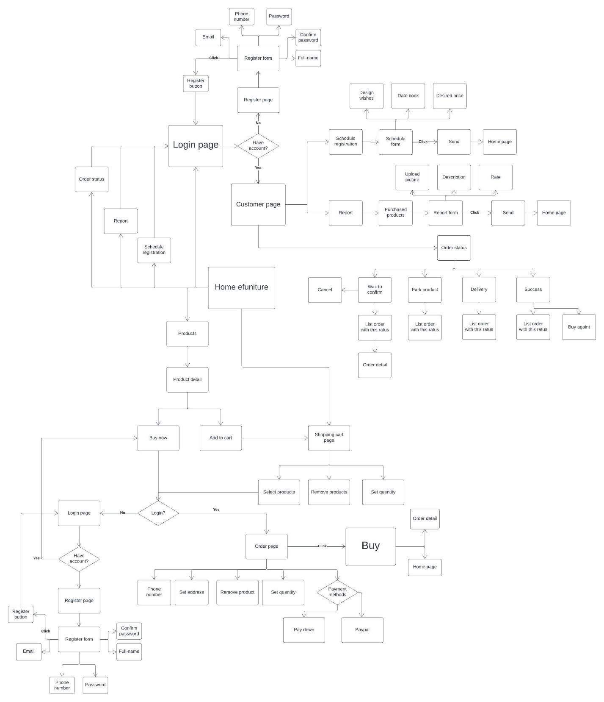

**7. Swimlane** 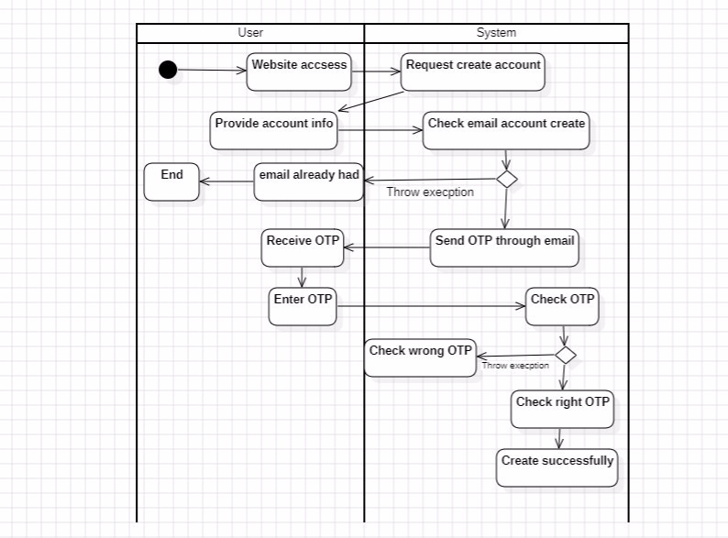

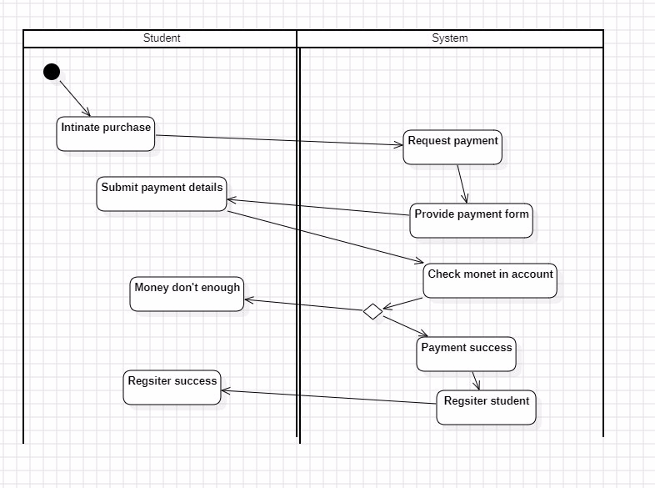

**8. State machine**

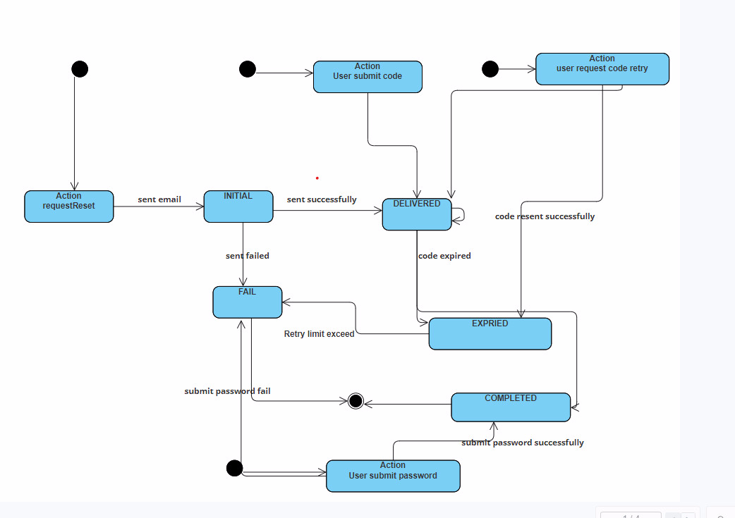

Untitled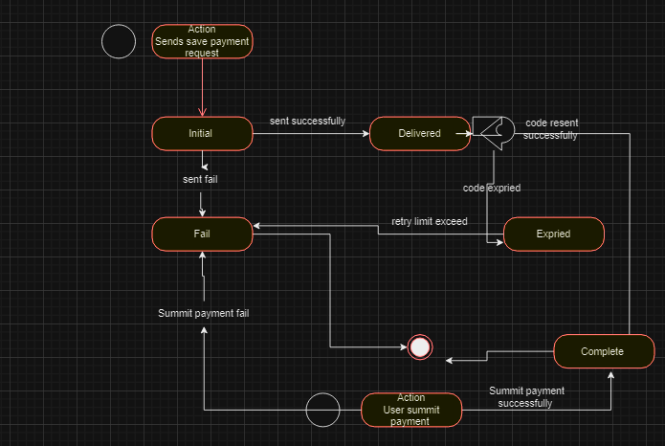

**9. Sequence diagram**

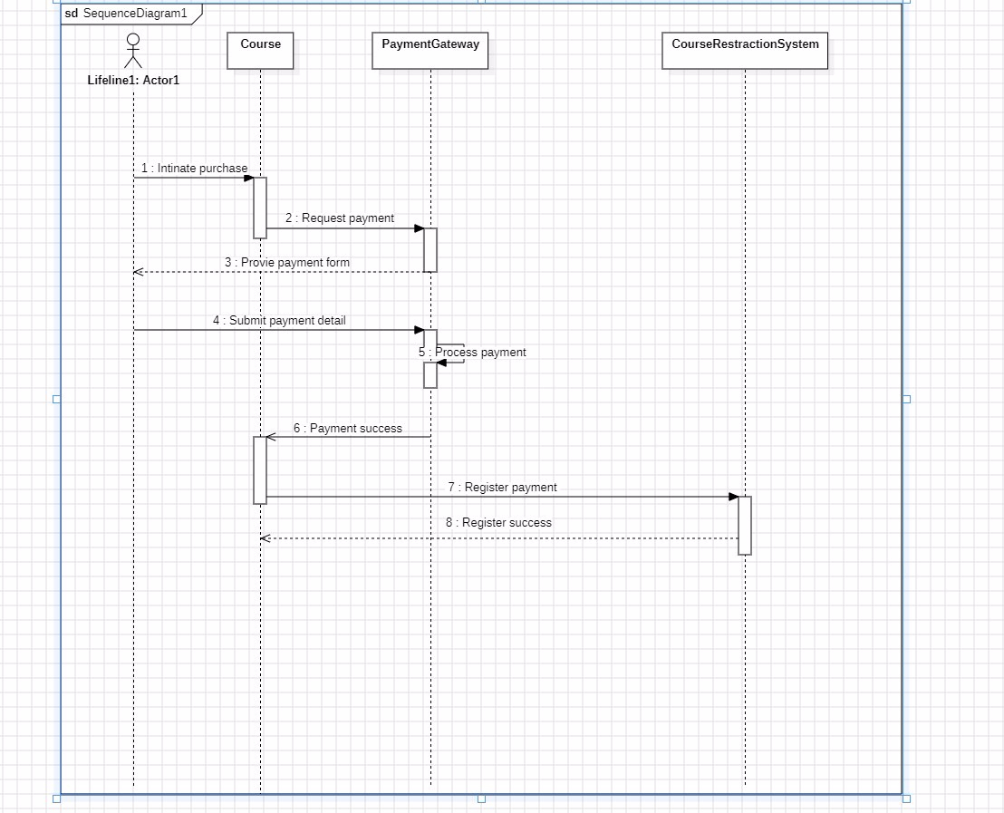

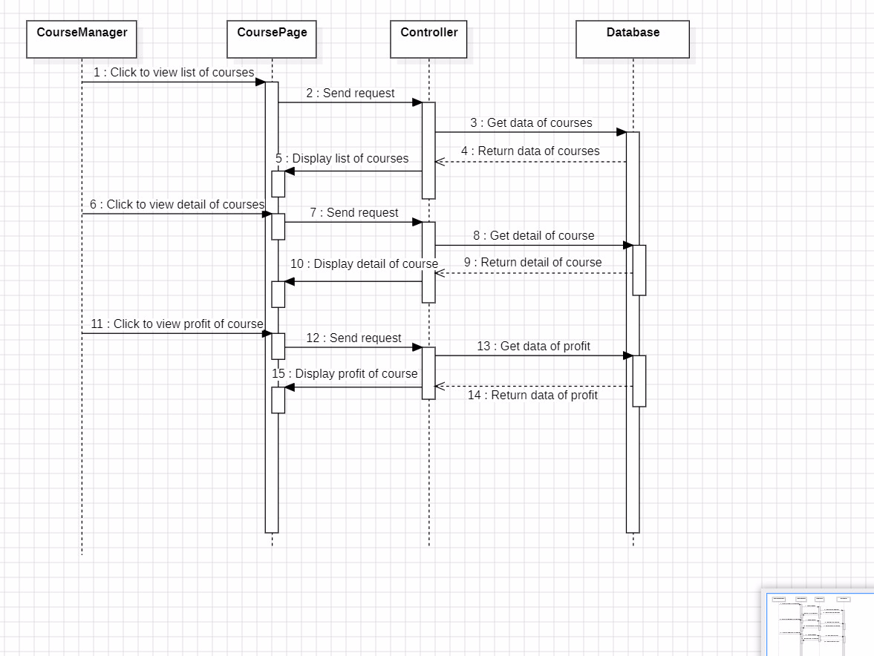

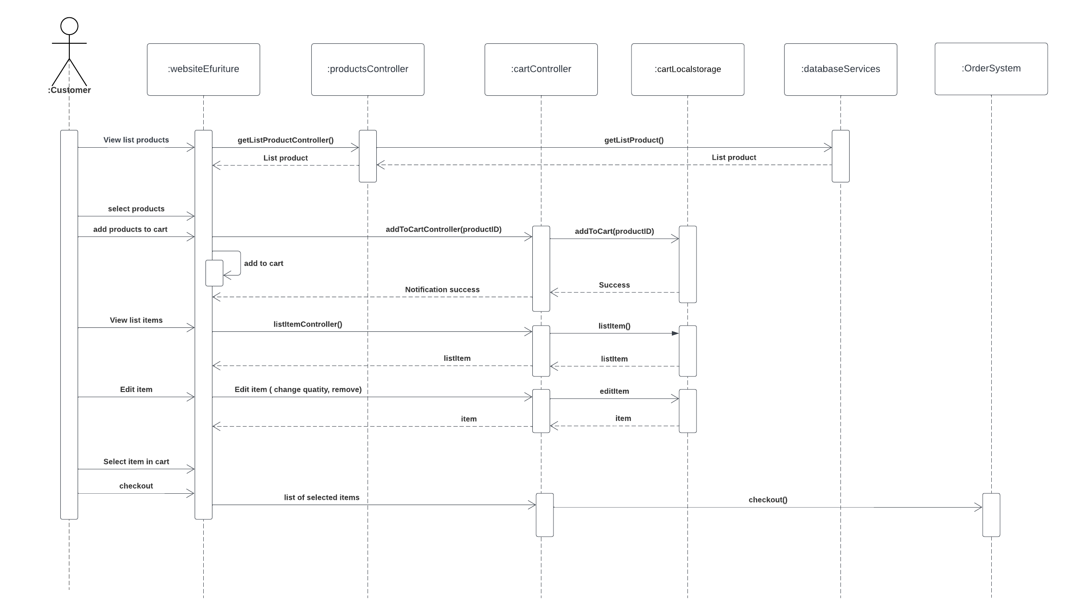

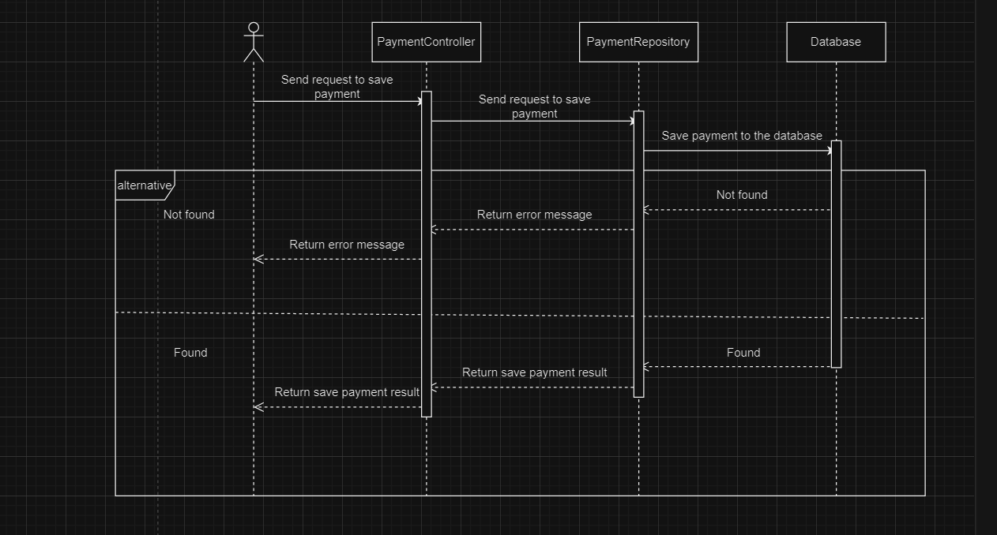

Untitled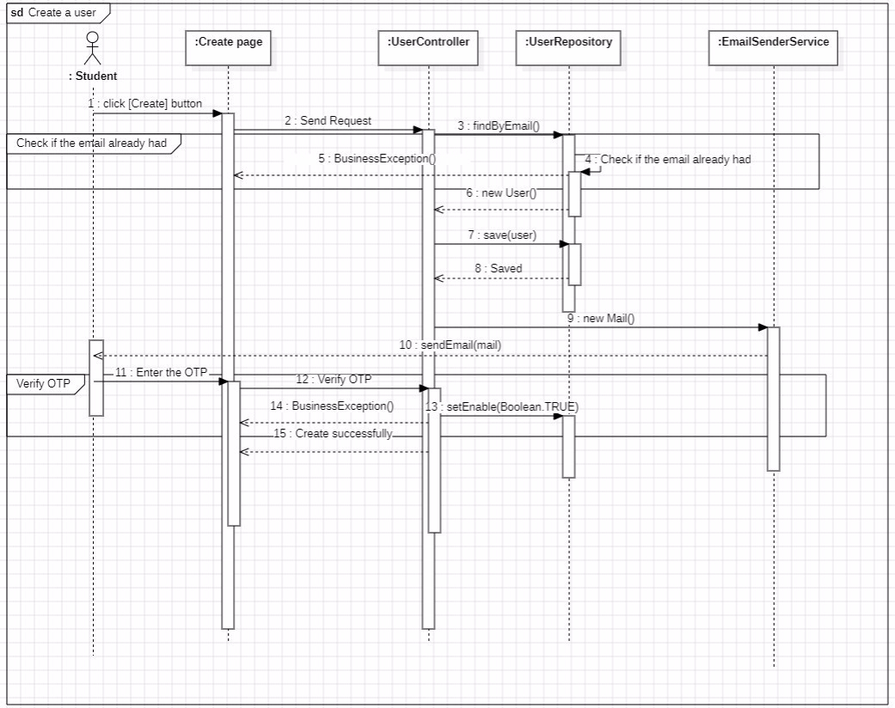

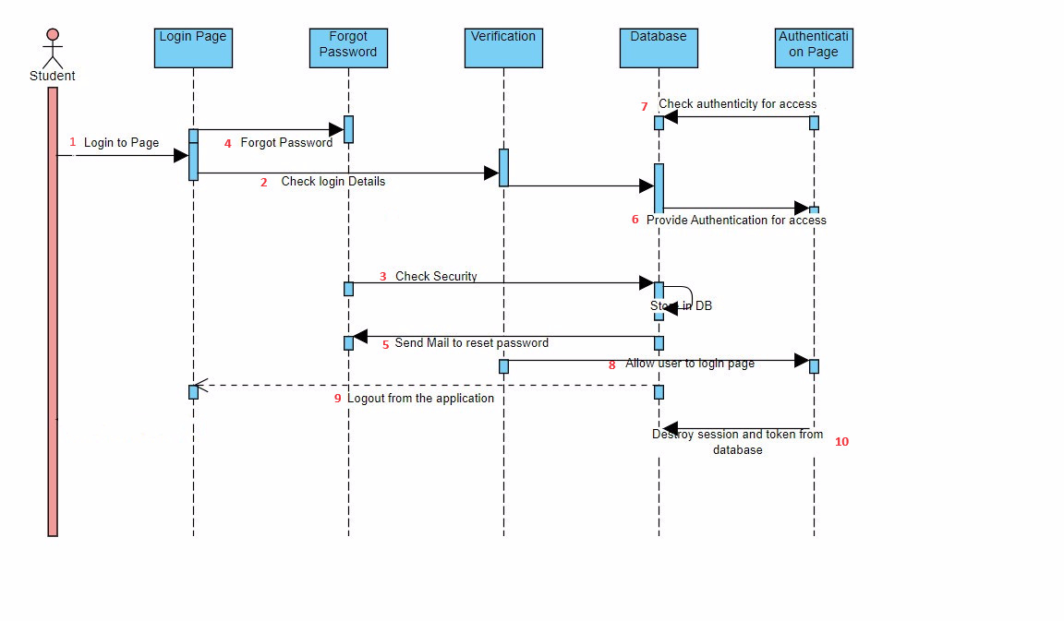

**10. Class diagram**

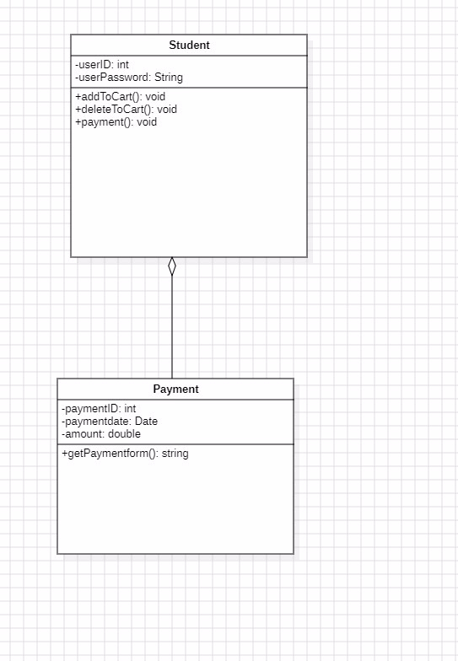

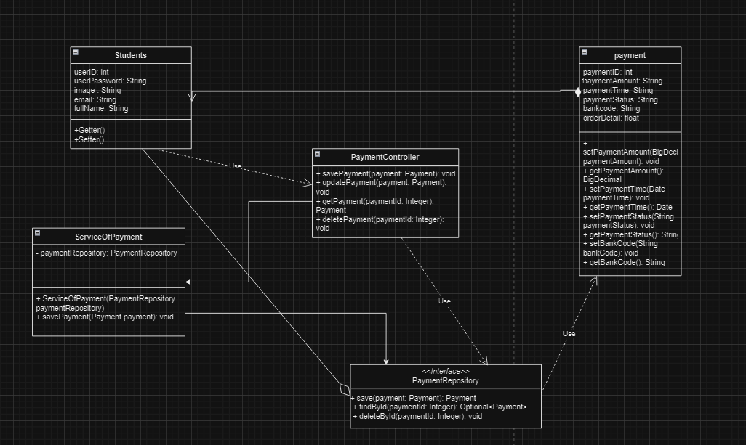

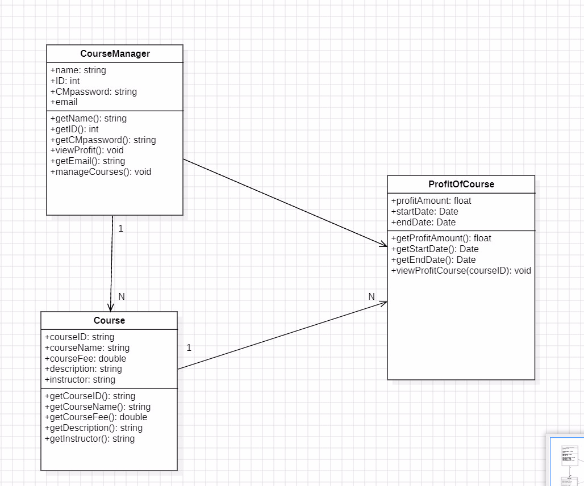

Untitled